Computer Networks

Complex Engineering Problem

Instructor name: Ma’am Mehwish Kiran.

Class: BESE-14A

Team Members:

Muhammad Hassan Ali (456628)

Faisal Iqbal ()

Muhammad Mudassir Bhatti()

**Introduction:**

An organization named netBuzz needs a network design. The organization has 3 floors and 4 departments.

The network should be designed in such a way that the departments can work independently of each other by communicating within and only communicating with other departments when needed.

The organization should also have servers to assign automatic IPs to the devices of clients and employees, host website, assign domain name, and establish communication through emails, as professional ethics.

Each floor should have printers, wireless and wired devices.

**Keyterms:**

* *VLANs: Virtual Local Area Networks, they are physically present in the same* *place, but are virtually divided into different networks.*
* *IP addresses: Internet Protocol addresses, these are numeric numbers, assigned to the end devices like computers, printers, etc. To differentiate them on the interent.*

**Layout:**

From the above information, it is clear that we need a topology as shown below, in out cisco packet tracer:

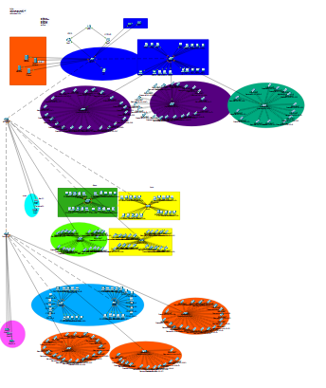

Well, it seems to be quite big and sufficient, as we are building the network for a company having three floors, 4 departments, and almost 500 devices. Now, let’s break down the components in the above design:

* Routers.
* Switches.
* Servers.
* Computers.
* Wireless access points.
* Printers.
* Mobiles.

Now, let’s explain each one of them one-by-one:

**Components**

1. **Routers:** The routers are created to establish connection internally between the VLANS, and externally with the whole internet. This work can be done by a single router, so why are there three routers in the design?  
   To answer this question, you need to understand that routers are machines which can die out due to overloading or some internal circuitry issue, in that case the other router connected to the switch will take its place and starts working until the first router gets fixed. So, we have one primary router, and one backup router.  
   Then, what is the third router for? It is just there to show the external interenet connection.   
   Note that the two interfaces of the primary and backup router connected to the external router are given the public IP addresses. These public IP addresses are the representation of the organization on the internet.
2. **Switches:** Switches are the components that connect the end devices with each other, and to the internet. These are the suppliers of what we call the internet to us.  
   They are also used to divide the network into VLANs, for data integrity and security.  
   They work at the core level and thus need to be well structured and connected.
3. **Servers:** These are the end devices which can provide any type of service to other end devices. The services include:

* IP allocation.
* Web hosting.
* Domain allocation.
* Email connectivity.

There are still more but we will only discuss these as these are the only ones needed.

1. **End devices:** In end devices, we have computers, printers, and mobiles, which belong to people and need internet connectivity for the whole functionality of the organization.
2. **Wireless Access Points:** These are the devices which are used to provide wireless internet connectivity to the devices that have a wireless card. They are connected to switches and serve as a bridge between switch and wireless devices.

**Implementation**

The whole implementation is divided into the following steps:

1. Create the topology of the first, second and third floor. Now introduce main switches at each floor.
2. Connect the main switch of first floor, with servers, the other switch, and the two routers.
3. Connect the main switch of the second floor with the switches of finance and administration department.
4. Connect the main switch of the third floor with the other two switches.
5. Make trunk connections between switchs and routers, at CLI mode of switches.
6. Create all VLANS in the main switch of the first floor; sales VLAN in the sales and services switch; finance, research & development and admin VLAN in the main switch of the second floor; finance VLAN in finance switch; admin VLAN in administration switch; research and development VLAN in main switch of third floor, and the other two switch of the third floor.
7. Now, go and create sub-interfaces in the router configuration for the VLANs, assign them ip addresses with proper subnetting, tell the subnets the IP address of the DHCP server, and then make the subnets standby with the default gateway IP addresses with one having high priority (primary) and the other having low priority (backup).
8. Now, go and create DHCP pools in the DHCP server. The devices on DHCP mode should start getting their IP addresses.
9. Now, go to the web server, services option, and HTTP tab. Edit the index.html file.
10. Now, go to the DNS server, and DNS services. Assign the IP address of the web server a domain name and check the domain name by typing the name on the web browser of any device having the DHCP IP.
11. Now go to the Email option of the Email server. Set the domain name, and enter users in that domain (atleast 2). Now, go to the email option of any end device having DHCP IP, log in from the registered users credentials and compose an email to any other registered user. Send the mail and check it on the email ID of the other user, ensuring successful connection.